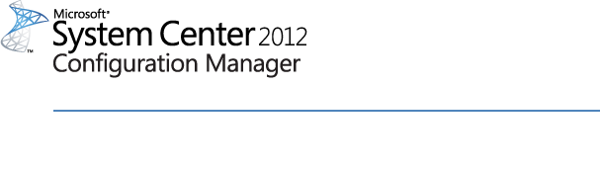

# Help for System Center 2012 Configuration Manager Toolkit R2

Microsoft Corporation

Published: November, 2013

# Copyright

This document is provided "as-is". Information and views expressed in this document, including URL and other Internet Web site references, may change without notice. You bear the risk of using it.

Some examples depicted herein are provided for illustration only and are fictitious.  No real association or connection is intended or should be inferred.

This document does not provide you with any legal rights to any intellectual property in any Microsoft product. You may copy and use this document for your internal, reference purposes. You may modify this document for your internal, reference purposes.

© 2012 Microsoft Corporation. All rights reserved.

Microsoft, Active Directory, Windows, and Windows Server are trademarks of the Microsoft group of companies.

All other trademarks are property of their respective owners.

# Contents

Help for System Center 2012 Configuration Manager Toolkit R2 1

Copyright 2

Contents 3

Help for System Center 2012 Configuration Manager Toolkit R2 4

History 4

Toolkit contents 4

System Requirements 5

1. Client Tools 6

1.1. Client Spy (CliSpy.exe) 6

1.2. Deployment Monitoring Tool 10

1.3. Policy Spy 14

Actual tab 16

Requested tab 16

Default tab 16

Events tab 16

1.4. Power Viewer Tool (powervwr.exe) 18

1.5. Send Schedule Tool (SendSchedule.exe) 19

1.6. Wakeup Spy 23

Operation – Viewing wake-up information 24

Operation – Configuration 25

Operation – Reporting 25

Limitations 26

2. Server tools 26

2.1. Security Configuration Wizard Template (ConfigMgrSCW.xml) 26

2.2. Role Based Administration Modeling and Auditing Tool (RBAViewer.exe) 27

2.3. Run Metering Summarization (runmetersumm.exe) 33

2.4. Content Ownership Manager Tool 34

2.5. Content Library Transfer Tool 36

2.6 Content Library Explorer Tool 37

2.7 Collection Evaluation Viewer (CEViewer.exe) 39

2.8 Distribution Point Job Queue Manager (DPJobMgr.exe) 44

# Help for System Center 2012 Configuration Manager Toolkit R2

This document is based on the Microsoft System Center 2012 Configuration Manager Toolkit R2. The toolkit contains downloadable tools to help you manage and troubleshoot System Center 2012 Configuration Manager R2.

## History

|  |  |
| --- | --- |
| Release Date | Changes |
| April 2012 | Original release of this guide |
| December 2012 | Second release of this guide |
| November 2013 | Third release of this guide |

## Toolkit contents

The Toolkit includes the following tools:

• License Agreement

* Documentation

• Client tools

* Client Spy
* Deployment Monitoring Tool
* Policy Spy
* Power Viewer Tool
* Send Schedule Tool
* Wakeup Spy
* Configuration Manager Trace (CMTrace)
* Server tools
* Security Configuration Wizard Template for System Center 2012 Configuration Manager
* Role Based Administration Modeling and Auditing Tool
* Content Ownership Manager
* Run Metering Summarization Tool
* Content Library Transfer
* Collection Evaluation Viewer

## System Requirements

Microsoft System Center 2012 Configuration Manager R2

[System Center 2012 Configuration Manager System Requirements](http://technet.microsoft.com/en-us/library/gg682077.aspx#BKMK_SupConfigSystemReqs)

# Client Tools

## Client Spy (CliSpy.exe)

Client Spy (CliSpy.exe) is a tool for troubleshooting software distribution, inventory, and software metering on computers running System Center Configuration Manager Client.

Most of the information retrieved by the tool pertains to software distribution. The tool displays all current software distribution program run requests, software distribution history, the client cache configuration, cached items, and pending mandatory program runs and lists optional programs that are available.

Inventory information that is displayed includes the latest inventory cycle date, the last report date, software inventory major and minor versions, the file collection, hardware inventory, the IDMIF collection, and discovery data records (DDRs).

Software metering rules are also displayed.

**Note**

To improve performance, information for each tab is collected only when it is selected. Similarly, when Refresh is clicked, only the information for the currently displayed tab is refreshed.

**Usage**

The main menu of the tool contains two buttons: **Tool** and **Edit**.

**The Tool Button**

Clicking **Tool** displays a drop-down menu containing the following menu options:

|  |  |
| --- | --- |
| Item | Description |
| Connect | Allows you to connect to a different computer to retrieve information. An account with sufficient credentials to obtain the information is required. The remote computer name, user name, and password for the account are required to make the connection. A connection to the IPC$ share on the remote computer is made and the connection is deleted when either the tool exits or you connect to another computer. By default, the tool displays information from the current computer. If you do not specify a user name and password, the security context of the currently logged-on user is used to attempt to make the connection. When you connect to a remote computer, all tabs that are displayed show information from the remote computer. |
| Software Distribution | Displays the Software Distribution tabs and hides the other tabs. By default, the Software Distribution tabs are displayed. |
| Inventory | Displays the Inventory tab and hides the other tabs. |
| Software Metering | Displays the Software Metering tab and hides the other tabs. |
| Save current tab to file | Saves information that is contained in the currently displayed tab to a text file after you specify a file name. |
| Save all tabs to file | Saves information that is contained in all tabs to a text file after you specify a file name. However, only information you \can see is saved. |
| Exit | Closes the tool. Any open IPC$ connections to remote computers are also closed. |

**Software Distribution Tabs**

You can configure settings on four tabs:

1. Software Distribution Execution Requests
2. Software Distribution History
3. Software Distribution Cache Information
4. Software Distribution Pending Executions

**Software Distribution Execution Requests Tab**

This tab displays all existing program run requests including system (computer) run requests and user run requests for all users, including the currently logged-on user.

Each tree item in the Software Distribution Execution Requests tab contains the following four attributes:

1. Advertisement ID. This might be blank, if it is an optional program run.
2. Package ID
3. Program Name
4. User. This might be the targeted user SID or the SID of the user who initiated the request, as it is stored in the run request. If both are system requests, the displayed user is System.

For each run request, the following information is also displayed in a sub tree structure:

1. Program Name
2. Package ID
3. Package Name
4. Request Creation Time
5. State
6. Running State, if State is Running
7. Execution Context (User or Admin)
8. History State (Success, Failure, or NotRun)
9. LastRunTime (Never, if the program has not been run before)
10. RetryCount, if State is WaitingRetry
11. ContentAccess (Retry Count, if State is WaitingRetry)
12. FailureCode, if State is WaitingRetry
13. FailureReason, if State is WaitingRetry

If the request requires content, the state is displayed as WaitingContent. Details for this download request are shown on the Software Distribution Cache Information tab.

If the run request is a download request, the number of bytes downloaded is also displayed.

**Note**

Different icons are displayed for varying states of a run request.

**Software Distribution History Tab**

This tab contains information about all previously run programs. This information is stored in the registry.

The main branches of this tree are the different user histories, including System. A subtree containing the list of packages from which programs have been run is displayed for each user.

The package ID and package name for each package subtree displays a list of programs that have been run. The program name, run state, last run time, failure code, and failure reason are displayed for each. The failure code and failure reason are blank when a program was successfully run.

**Software Distribution Cache Information Tab**

There are three main items on this tab: Cache Config, Cached Items, and Downloading Items.

1. **Cache Config** - Contains information about the System Center Configuration Manager Client cache, including the cache location, the cache size, and whether the cache is currently in use.
2. **Cached Items** - Contains a subtree of all items currently in the cache. Each tree item is identified by its location (folder) and displays state, package ID, package name, package version, package size, current reference count, and the last referenced time.

**Note**: The last referenced time is displayed as GMT.

1. **Downloading Items** - These are the items currently being downloaded. Each of them, besides the information displayed by the cached items, also displays the number of kilobytes downloaded.

**Software Distribution Pending Executions**

This tab contains information that details past and future scheduled program runs and a list of optional programs that are available.

Each tree branch is for each user account with programs available, including System.

For each user, a sub tree contains the following three items:

1. **Mandatory Advertisements With Future Executions** - These are mandatory advertisements that still have programs remaining to be run. These can be either recurring, one-time, or multiple schedule advertisements. Each displays the advertisement ID, the next run time, and the schedule on which the advertisement runs.
2. **Optional Advertisements** - Displays a list of all advertisements that are published. Details such as advertisement ID, program name, and package name for each are also displayed.
3. **Past Mandatory Advertisements With No Future Scheduled Executions** - This is a list of advertisements that exist on the client that have no future programs scheduled to run. The advertisement ID, package name, and program name are displayed. A subtree item is displayed for any advertisements that are optional.

**Note**

Package name information is only available for packages that have advertised policies associated to them on the computer being viewed. Packages that no longer have available policies associated to them display the message **“Package Name No Longer Available”.**

**Inventory Tab**

There is only one tab containing inventory information. The main tree contains the following five items:

1. **Software Inventory** - Contains the date that the last cycle started, the date of the last report, and the minor and major versions of the last report.
2. **File Collection** - Contains the date that the last cycle started, the date of the last report, and the minor and major versions of the last report.
3. **Hardware Inventory** - Contains the date that the last cycle started, the date of the last report, and the minor and major versions of the last report.
4. **IDMIF Collection** - Contains the date that the last cycle started, the date of the last report, and the minor and major versions of the last report.
5. **DDR** - Contains the date that the last cycle started, the date of the last report, and the minor and major versions of the last report. The DDR information is also displayed in a subtree.

**Software Metering Tab**

Information on this tab is displayed in the form of a subtree. It contains all software metering rules. Each rule, displayed as a node, is identified by the file name and rule ID. By expanding each node in the tree, the following information is also displayed:

1. Explorer file name
2. Original file name
3. Rule ID
4. File version
5. Language

**The Edit Button**

Clicking **Edit** displays a drop-down menu containing the following menu item:

|  |  |
| --- | --- |
| Item | Description |
| Refresh | Refreshes the information contained in the currently displayed tab. All other tabs are unaffected. |

## Deployment Monitoring Tool

The Deployment Monitoring Tool is a graphical user interface designed to assist in troubleshooting applications, updates, and baseline deployments on a System Center Configuration Manager 2012 managed client. The tool is **read only**; it does not change any state on the client and can be safely used to diagnose common deployment scenarios.

The Deployment Monitoring Tool is designed to **run as** an administrator for the computer the administrator wants to troubleshoot.

Some of the features enabled in the Deployment Monitoring Tool are:

1. Run asan administrator to troubleshoot deployments on a local client.
2. Launch the tool; connect to a remote machine as administrator to troubleshoot deployments on a remote client.
3. Export all the data collected in the tool to XML. The XML file serves as a ship vehicle for data collected by the tool and serves as a common platform for talking about troubleshooting deployments.
4. Import previously exported data to a different machine and use it to run the tool in offline mode

**Usage**

Deployment Monitoring Tool supports graphical user interface only. Run the “DeploymentMonitoringTool.exe” to launch the tool and run as administrator.

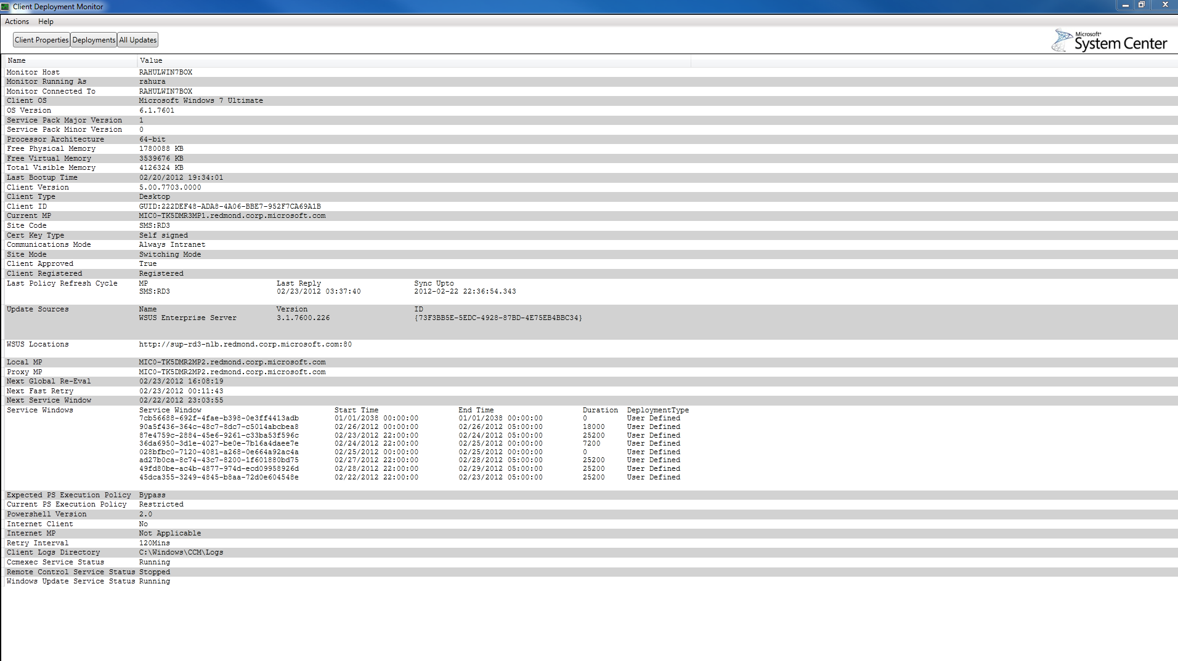A successful launch should look like:

To view all deployments targeted: Click **Deployments** button near the top of the window. There are also other tabs that show sub categories information.

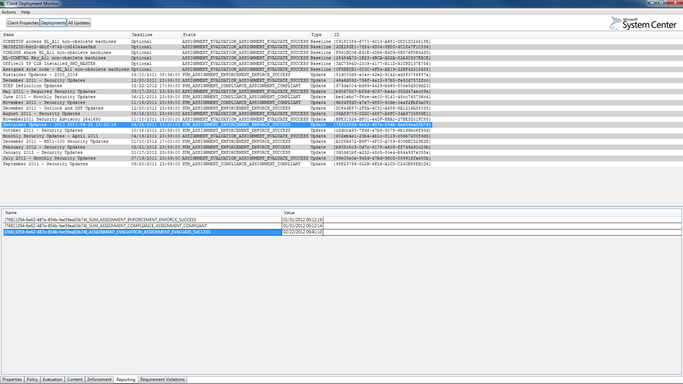

To view all updates and theirs status: Click **All Updates** button near the top of the window

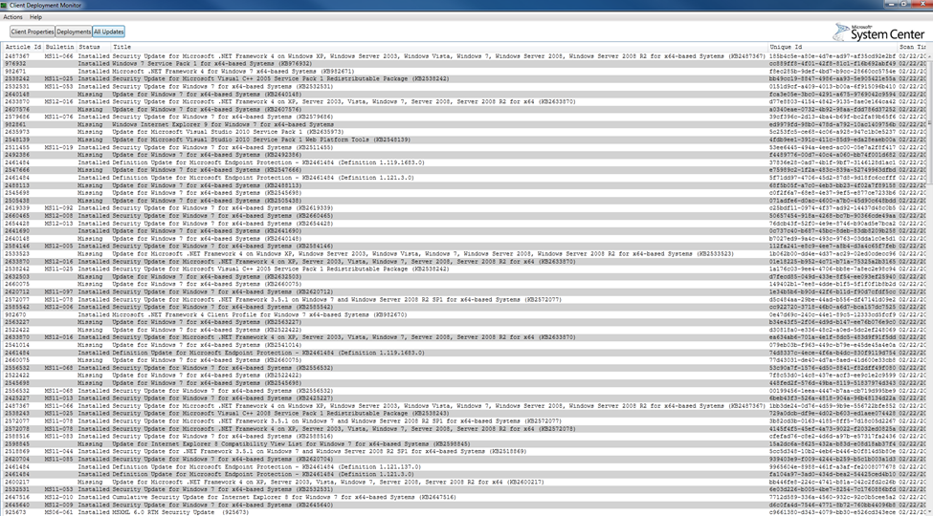

To return to the launch view: Click **Client Properties** near the top of the window

**Menu Items**

The following table describes the options available when selecting **Actions** and **About** from the menu.

|  |  |
| --- | --- |
| Tools Menu Option | Description |
| Connect to Remote Machine | Selects a computer to connect to. When user name and password are not specified, it will use the current credentials. Click **Save** to connect to remote computer |
| Export Data | Selects the file to write the data into and click **Save**. Use the exported xml file for remote troubleshooting on a different computer |
| Import Data | Selects file to import into the tool |
| View Log | Log files include:  **PolicyAgent.log:**Application and Baseline Deployments  UpdatesDeployment.log: Update Deployments  WindowsUpdate.log: All Updates . |
| Refresh | Refreshes all data |
| About | Opens the about dialog |

## Policy Spy

Policy Spy is a tool for viewing and troubleshooting the policy system on System Center 2012 Configuration Manager Clients

**Important**

Policy Spy must be run as an administrator.

**Syntax**

Although Policy Spy is primarily intended for use through its user interface, it does provide limited command-line options to support automation and batch processing.

PolicySpy.exe [/export <ExportFilename> [<computername>]]

|  |  |
| --- | --- |
| Option | Description |
| /export | This option silently exports the policy of the local or remote computer. <ExportFilename> is the file name that is used to save the XML exported policy. If the <computername> option is provided, Policy Spy exports the policy of that computer, instead of the local computer.  **Note:** This command-line option does not provide a way to specify user credentials. If you must use alternative credentials to access a remote computer, you should use the **runas** command to open a new command prompt with the required security credentials. |

**Menu Options**

There are two menu options that you can select: **Tools** and **Edit**. The following table describes the options available when selecting Tools from the menu.

|  |  |
| --- | --- |
| Tools Menu Option | Description |
| Open Remote | Connects to the policy on a remote computer. Use the Connect dialog box to retrieve the name of the remote computer system and optional user credentials. If the connection fails, error information is displayed in the Client Info pane. If the connection fails again, you can try connecting by selecting Refresh on the **Edit** menu or by pressing F5. |
| Open File | Opens a policy export file (.xml) created by the **Export Policy** option. The exported policy is viewed exactly the same as a live policy except some features that only apply when connected to an actual client are disabled. |
| Request Machine Assignments | Triggers a request for machine policy assignments on the target computer system. This feature is disabled when viewing exported policy. |
| Evaluate Machine Policy | Triggers a machine policy evaluation on the target computer system. This feature is disabled when viewing an exported policy. |
| Request User Assignments | Triggers a request for user policy assignments for the logged-on user. This feature is only available when viewing a policy on the local computer. |
| Evaluate User Policy | Triggers a user policy evaluation for the logged-on user. This feature is only available when viewing a policy on the local computer. |
| Reset Policy | Removes all non-default policies and resets the policy cookies for the site. It then triggers a request for machine policy assignments. This feature is disabled when viewing an exported policy. |
| Export Policy | Exports the target computer system's policy to an XML-format export file. This file can be viewed on any computer by selecting **Open File** on the **Tools** menu and opening the export file. This feature is disabled when viewing an exported policy. |

The following table describes the options available when selecting Edit from the menu.

|  |  |
| --- | --- |
| Edit Menu Option | Description |
| Delete | Deletes the instance selected in the **Results** pane. This is only supported for policy instances. An error message is displayed if you try to delete anything other than policy instances. This feature is disabled when viewing an exported policy. |
| Refresh | Refreshes all results to ensure that you are viewing the latest information. All tree nodes that are expanded before refreshing are automatically expanded afterward. If Policy Spy has not successfully connected to the target computer's policy, Policy Spy tries to connect again. This feature is disabled when viewing an exported policy. |
| Clear Events | Clears all items from the Events tab. |

**Results Pane**

The results pane displays different views of the policy system on the target computer. These views are accessed by clicking on one of the following four tabs: **Actual**, **Requested**, **Default**, and **Events**.

#### Actual tab

This tab displays the current policy of the client. The current policy determines a client's behavior and the behavior of its client agents, such as software distribution and inventory. Results are displayed in a tree format with a root node for the computer namespace and each user-specific namespace. Expanding a namespace node displays a list of classes. You can expand a class to display a list of its instances. The class list contains only classes that have instances.

#### Requested tab

This tab displays the policy assignments that were retrieved from the client's assigned site. Results are displayed in tree format with a root node for the Machine namespace and each user-specific namespace. Expanding a namespace node displays the Configuration and Settings nodes.

1. **Configuration node** - displays a list of configuration classes derived from CCM_Policy_Config, which includes policy object, assignments, and others.
2. **Settings node** - Expanding the Settings node displays all active settings generated by policies. Settings are displayed under the Configuration node.

**Note**

Multiple instances can exist with the same names because these settings have not been merged into a final resultant set. Policy Spy displays instances under this node by using the RealKey properties instead of their true policy keys so they can be easily correlated to the resultant set displayed on the Actual tab.

#### Default tab

This tab displays the same information that the **Requested** tab does as well as the contents of the DefaultMachine and DefaultUser namespaces.

#### Events tab

This tab displays policy agent events as they happen. The view creates a WMI event subscription for all events derived from CCM_PolicyAgent_Event. The view shows a maximum of 200 events and removes the oldest events from the top of the list, as required. If the last item in the list is selected, the list automatically scrolls down as new events are added. Otherwise, the view maintains its current position and you must scroll down or press the End key to view new events. This view is always empty when viewing an exported policy.

**Client Info Pane**

The Client Info pane displays a list of properties for the target computer. The following properties are displayed:

|  |  |
| --- | --- |
| Property | Description |
| Name | The computer name of the Configuration Manager client. |
| ID | The unique identifier of the client as assigned by Configuration Manager. |
| Version | The version number of the Configuration Manager client. |
| Site | The name of the Configuration Manager client's assigned site, if the client is assigned to a Configuration Manager site. |
| Assigned MP | The name of the Configuration Manager client's assigned management point. |
| Resident MP | The name of the Configuration Manager client's resident, or local, management point. |
| Proxy MP | The name of the Configuration Manager client's proxy management point. |
| Proxy State | The state of the Configuration Manager client's proxy management point, such as Active or Pending. |

**Details Pane**

The Details pane displays detailed information about the current selection. If no selection is active, it displays information about Policy Spy itself, including the version and copyright information. Otherwise, it displays a Manage Object Format (MOF) representation of the selected item.

Policy Spy uses its own MOF-generation routine to generate a more user-friendly HTML display than the plain-text MOF generated by WMI. This allows Policy Spy to add the following features to make the MOF more legible:

1. Syntax highlighting.
2. Indented subobjects and arrays.
3. Properties are arranged into system, inherited, and local groups. The system and inherited groups are collapsed by default, so that you can immediately see which properties the instance actually uses.
4. The use of Copy MOF to clipboard to copy plain-text MOF to the Windows clipboard. This is useful for pasting MOF into other applications by directly calling the MofComp tool.

For instances of Policy objects derived from CCM_Policy_Policy, the details pane displays the policy body below the MOF that displays. If the body has not been downloaded by the client, Policy Spy displays a hyperlink so you can download the policy body directly from the client's management point. Clicking the link causes Policy Spy to send an HTTP query to the management point. If the policy body download succeeds, the hyperlink is replaced with the contents of the reply. Otherwise, the display is updated indicating that the request failed.

## Power Viewer Tool (powervwr.exe)

The Power Viewer tool will help administrators view the status of power management feature on client side.

**Usage**

To run the application, users must run as administrators.

When the application launches, it will display the power settings and capabilities data of local computer.

To view the power management data of remote computers: click **File** and then click **Connect** to connect to the remote computer that you want to view the power management data of...

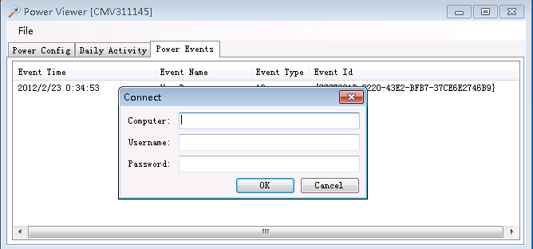

**Detailed description**

This tool can be used for:

1. Viewing the power capability status
2. Viewing the daily activity charts in the client, which includes
   * **Computer on**: Power status of computer in one day. Sleep mode is considered as power off.
   * **Monitor on**: On or off status of monitor in one day,
   * **User Active**: User activity information in one day.
3. Viewing all of the daily power events. These events will be summarized at 12:00 AM, which will generate data for daily activity chart.

## Send Schedule Tool (SendSchedule.exe)

The Send Schedule tool is used to trigger a schedule on a Client or trigger the evaluation of a specified DCM Baseline. You can trigger a schedule either locally or remotely.

For example, you can use the tool to trigger an inventory schedule or evaluate a specified DCM Baseline. If a number of SMS Clients have not reported inventory or DCM status recently, you can run the tool to initiate the necessary schedule on each client.

**Usage**

SendSchedule must be run as an administrator.

SendSchedule /L [Computer Name]

SendSchedule "" [Computer Name]

**Options:**

/L - List all Message GUID or DCM UID available for sending.

Display the meaningful name of messages in the data table for each one.

If computer name is absent, the local computer will be used by default.

If the message is specified without machine name then the message is sent to the local machine.

**Examples:**

**List available message on MyPC**

SendSchedule /L MyPC

**Send Schedule {00000000-0000-0000-0000-000000000001} to MyPC**

SendSchedule {00000000-0000-0000-0000-000000000001} MyPC

**Trigger Specified DCM evaluation in MyPC**

SendSchedule ScopeId_611E8382-C064-4B62-B0DE-EFFB52AE8994/Baseline_36722778-69dd-4423-9632-b61148b2b67e MyPC

**List available messages on local machine**

SendSchedule /L

**Send Schedule {00000000-0000-0000-0000-000000000001} to local machine**

SendSchedule {00000000-0000-0000-0000-000000000001}

**Message Mapping List of SendSchedule**

After trigger message, SMSClientMethodProvider.log which locate in “\Logs” will record the following process.

After you trigger DCM Evaluation, DCMAgent.log which locate in “\Logs” will record the process of evaluation.

|  |  |
| --- | --- |
| Message ID | Original Name | Display Name |
| {00000000-0000-0000-0000-000000000001} | HARDWARE_INV_ACTION_ID Hardware Inventory |
| {00000000-0000-0000-0000-000000000002} | SOFTWARE_INV_ACTION_ID Software Inventory |
| {00000000-0000-0000-0000-000000000003} | DISCOVERY_INV_ACTION_ID Discovery Inventory |
| {00000000-0000-0000-0000-000000000010} | FILE_COLLECTION_ACTION_ID File Collection |
| {00000000-0000-0000-0000-000000000011} | IDMIF_COLLECTION_ACTION_ID IDMIF Collection |
| {00000000-0000-0000-0000-000000000021} | POLICYAGENT_REQUEST_MACHINE_ASSIGNMENTS_ID Request Machine Assignments |
| {00000000-0000-0000-0000-000000000022} | POLICYAGENT_EVALUATE_MACHINE_POLICIES_ID Evaluate Machine Policies |
| {00000000-0000-0000-0000-000000000023} | LS_SCHEDULEDCLEANUP_REFRESH_DEFAULT_MP_TASK_ID Refresh Default MP Task |
| {00000000-0000-0000-0000-000000000024} | LS_SCHEDULEDCLEANUP_REFRESH_LOCATIONS_TASK_ID LS (Location Service) Refresh Locations Task |
| {00000000-0000-0000-0000-000000000025} | LS_SCHEDULEDCLEANUP_TIMEOUT_REFRESH_TASK_ID LS Timeout Refresh Task |
| {00000000-0000-0000-0000-000000000031} | SWMTR_USER_REPORT_GENERATION_ID Software Metering Generating Usage Report |
| {00000000-0000-0000-0000-000000000032} | SOURCE_UPDATE_MESSAGE_ID Source Update Message |
| {00000000-0000-0000-0000-000000000037} | Schedule for clearing proxy settings cache Clearing proxy settings cache |
| {00000000-0000-0000-0000-000000000040} | [Machine Policy schedules] PolicyAgent_Cleanup Machine Policy Agent Cleanup |
| {00000000-0000-0000-0000-000000000042} | [Machine Policy schedules] PolicyAgent_RequestAssignments Policy Agent Validate Machine Policy / Assignment |
| {00000000-0000-0000-0000-000000000051} | Schedule for retrying/refreshing certificates in AD on MP Retrying/Refreshing certificates in AD on MP |
| {00000000-0000-0000-0000-000000000061} | PDP_STATUS_REPORTING_SCHEDULE_ID Peer DP Status reporting |
| {00000000-0000-0000-0000-000000000062} | PDP_PENDING_PACKAGE_CHECK_SCHEDULE_ID Peer DP Pending package check schedule |
| {00000000-0000-0000-0000-000000000063} | SUM_UPDATES_INSTALL_SCHEDULE_ID SUM Updates install schedule |
| {00000000-0000-0000-0000-000000000071} | NAP_ACTION_ID NAP Action |
| {00000000-0000-0000-0000-000000000108} | SOFTWARE_UPDATES_POLICY_ACTION_ID Software Updates Policy Action Software Updates Assignments Evaluation Cycle |
| {00000000-0000-0000-0000-000000000109} | PDP_MAINTENANCE_POLICY_ACTION_ID PDP Maintenance Policy Branch Distribution Point Maintenance Task |
| {00000000-0000-0000-0000-000000000110} | DCM_POLICY_ACTION_ID DCM policy |
| {00000000-0000-0000-0000-000000000111} | STATE_SYSTEM_POLICY_BULKSEND_ACTION_ID Send Unsent State Message |
| {00000000-0000-0000-0000-000000000112} | STATE_SYSTEM_POLICY_CACHECLEANOUT_ACTION_ID State System policy cache cleanout |
| {00000000-0000-0000-0000-000000000113} | UPDATE_SOURCE_POLICY_ACTION_ID |
| {00000000-0000-0000-0000-000000000114} | UPDATE_STORE_POLICY_ACTION_ID Update Store Policy |
| {00000000-0000-0000-0000-000000000115} | STATE_SYSTEM_POLICY_BULKSEND_HIGH_ACTION_ID State system policy bulk send high |
| {00000000-0000-0000-0000-000000000116} | STATE_SYSTEM_POLICY_BULKSEND_LOW_ACTION_ID State system policy bulk send low |
| {00000000-0000-0000-0000-000000000120} | AMT_STATUS_CHECK_POLICY_ACTION_ID AMT Status Check Policy |
| {00000000-0000-0000-0000-000000000121} | APPMAN_POLICY_ACTION_ID Application manager policy action |

## Wakeup Spy

The Wakeup Spy tool provides a view of the power state of the Configuration Manager client peer computers and which computers are operating as managers or managees on that client computers’ subnet. The tool is a Windows application. The tool is useful to get an understanding of wake up traffic being generated and the current power status of client computers. It cannot be used to control the power state of computers, nor can it change or designate the computers used as guardians, managers or mangees.

**Usage**

**Wakeupspy.exe** can be run with or without an account that has administrative permissions on a computer system with the Configuration Manager agent installed.

**Syntax**:

Wakeupspy.exe

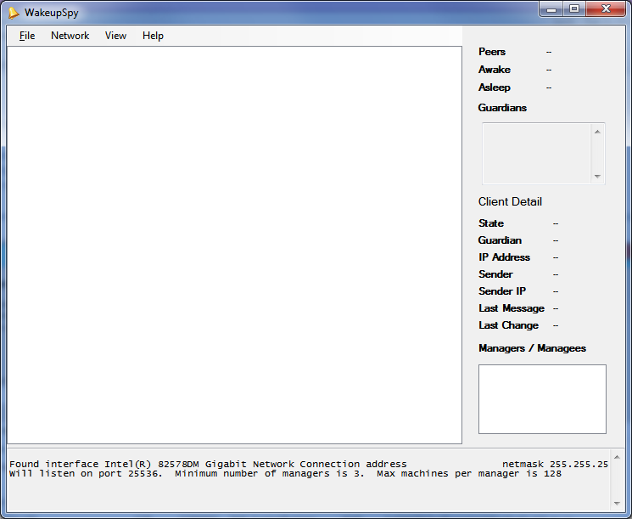

### Operation – Viewing wake-up information

1. Launch the tool from the Configuration Manager Toolkit folder created during installation.
2. Select the Network menu, and choose Listen
3. Wakeup Spy is now listening to wakeup network traffic generated by other computers. As the tool gathers information, it categorizes the systems into two groups – “Alseep” or “Awake”.
   1. “Awake” computers are Windows computers whose current power state is not sleep, hibernate or powered-off.
   2. “Asleep” computers are Windows computers whose current power state is sleep, hibernate or powered-off. The tool reports the sleep state from a peer or manager computer about the computers it is managing.
4. The main viewing pane will display a dynamic list of computers and their current state. By using the View menu, this list view can be changed to a list, display or group style.
5. The right hand pane contains summary information about the network subnet that the client computer is connected to. For example, it will display the number of peer computers in the same subnet, and update the number of systems that are awake or asleep within the subnet.
6. When a computer is selected in the main list view, the details for that computer are displayed on the right hand pane. For example, the IP address, current power state, and any managers for the computer are displayed.
7. The lower pane contains the network traffic information captured by the tool, and continuously updates as new information is received.

### Operation – Configuration

To configure Wakeup Spy, select the Network menu, and choose Configure. The currently selected network interface information is shown.

* 1. **Interface** - This setting can be changed to reflect other network interfaces on the client computer.
  2. **Netmask** – This is the network mask associated with the selected network interface. It can be changed to reflect another network interface on the client computer.
  3. **Port** – this is the listening port used by Wakeup Spy. It must match the configured port for wake up traffic generated by the Configuration Manager client.
  4. **Minimum number of managers** – This is the minimum number of manager computers which will stay awake. These are also referred to as guardians. Changing this number does not affect how the Configuration Manager agent determines managers or managees, but only how Wakeup Spy reports the information.
  5. **Max machines per manager** - This is the maximum number of manager computers displayed in Wakeup Spy as Wakeup Spy gathers its information. These are also referred to as guardians. Changing this number does not affect how the Configuration Manager agent determines managers or managees.
  6. **Read Policy** – The “Read Policy” button triggers the Wakeup Spy tool to read the Configuration Manager client settings policy for Wakeup. It can be used to re-set the configuration of Wakeup Spy to use the same settings as the Configuration Manager agent if they have been altered in the tool.

### Operation – Reporting

To output a report of the computers, their IP address and their current state, select the File menu, and choose “Save Report”. Specify the filename and location for the report.

### Limitations

1. Wakeup Spy cannot listen to network traffic if the Configuration Manager service is running. Stop the service using the Services MMC snap in, or type “NET STOP “configmgr wake-up proxy “ from a command prompt that has administrative permissions.
2. To stop Wakeup Spy from listening, close Wakeup Spy.

# Server tools

## Security Configuration Wizard Template (ConfigMgrSCW.xml)

The Security Configuration Wizard (SCW) is an attack-surface reduction tool for the Microsoft Windows Server 2008 R2 operating system. Security Configuration Wizard determines the minimum functionality required for a server's role or roles, and disables functionality that is not required. The System Center 2012 Configuration Manager Security Configuration Wizard template supports new site system definitions and enables the required services and ports.

The Security Configuration Wizard for System Center 2012 Configuration Manager Template provides support for the following site systems:

* Central Administrator Site
* Primary Site Sever
* Secondary Site Server
* Management Point
* Enrollment proxy Point
* Application Catalog Website Point
* Application Catalog Web Service Point
* Fallback Status Point (FSP)
* State Migration Point (SMP)
* Software Update Point (SUP)
* System Health Validator (SHV)
* Endpoint Protection point
* Out of Band Service Point
* Asset Intelligence Synchronization Point
* Enrollment Point
* Reporting Point
* Manager Client

**Technical Information**

Details on how to use, to select, and to apply Security Configuration Wizard settings can be found in the Security Configuration Wizard documentation linked below.

For more information about the Windows Server 2008 Security Configuration Wizard tool, see <http://technet.microsoft.com/en-us/magazine/2008.03.securitywatch.aspx>.

For an overview of the Security Configuration Wizard tool, see <http://go.microsoft.com/fwlink/?LinkId=102841>.

For additional information about Security Configuration Wizard and common FAQ’s, see <http://go.microsoft.com/fwlink/?LinkId=102843>.

**Install the Template**

To install the template into the SCW tool, Copy ConfigMgrSCW.xml from the System Center 2012 Configuration Manager Toolkit installation folder (ex. C:\Program Files (x86)\ConfigMgr 2012 Toolkit\ServerTools) to C:\windows\security\msscw\kbs and then copy ConfigMgrSCWHelper.dll should be copied to C:\windows\security\msscw\bin.

**Register the Template**

In a cmd prompt, running in an administrative context on the local server:

1. Unregister any prior Configuration Manager templates by entering:

"scwcmd register /d /kbname:ConfigMgr "

1. Register the new Configuration Manager Template by entering:

"scwcmd register /kbname:ConfigMgr /kbfile:c:\windows\security\msscw\kbs\ConfigMgrSCW.xml"

**Note**

You must run the scwcmd as a local administrative on the target server.

**Apply Security Options**

There are several options available in the Security Configuration Wizard tool for saving and applying the selected security options. Please reference the Security Configuration Wizard documentation for the application options and select the best solution for your systems environment.

If you’re using Windows Server 2008 SP2, after installing the msi, go to %windir%\security\msscw\kbs, edit ConfigMgrSCW.xml and change ServicePackMajorVersion="1" to ServicePackMajorVersion="2" at the fourth line.

## Role Based Administration Modeling and Auditing Tool (RBAViewer.exe)

The Role Based Administration Modeling tool:

1. Models Role Based Administration (RBA) security roles with specific permissions.
2. Audits what Role Based Administration (RBA) security scope and security role other users have.

**Installation requirements**

* This tool must be running on the same computer as System Center 2012 Configuration Manager Console.
* The user has to be a Full Administrator, Read-only Analyst, or Security Administrator..
* The user has to be assigned to **All security scope** and **All collections**..
* (Optional)To analyze report folder security, user must have SQL access.
* (Optional)To analyze report drill through, user must run this tool on the site with reporting services point installed.

**To Model Permissions for a New Role that an Administrator wants to create**

1. Start the RBA modeling and auditing tool.
2. Select the base security roles you want to build on or start from an empty permission set. Check or uncheck whatever permission you want.
3. Click **Analyze**  to see the UI this custom role will see.

Note

You can also check the similarity of security roles to see whether there is an existing security role to meet your requirements. click.

1. Click **Export** to save the role as an XML file and import it from the Configuration Manager Console.

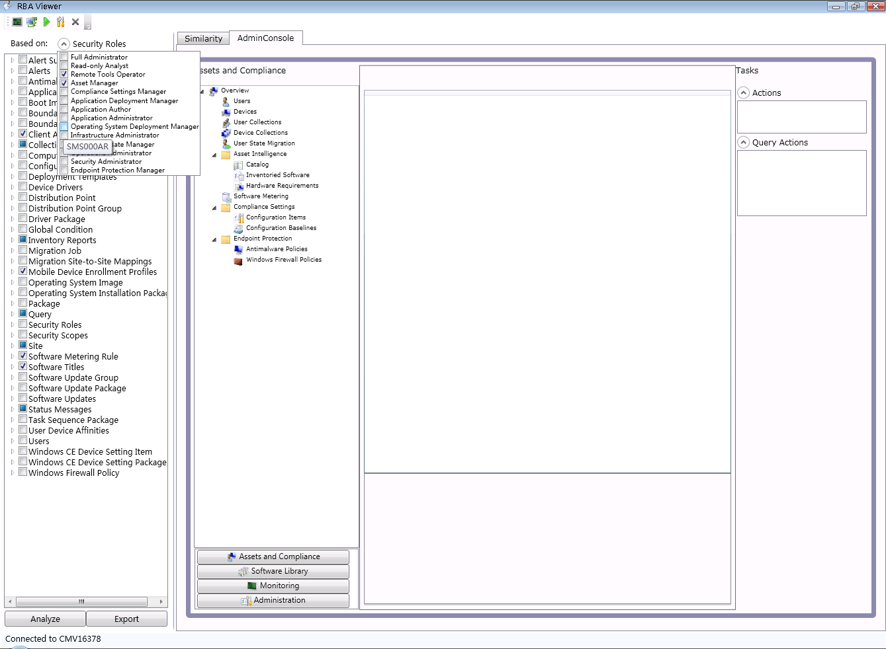

**To Audit all Existing Administrative Users/Collections Hierarchy/Security scopes in Configuration Manager**

Select the Audit RBA button in toolbar tray.

* Select the **Collection Summary** tab to view the collection limited relationship in a tree view.
* Select the **Scopes Summary** tab to view objects assigned to a security role.

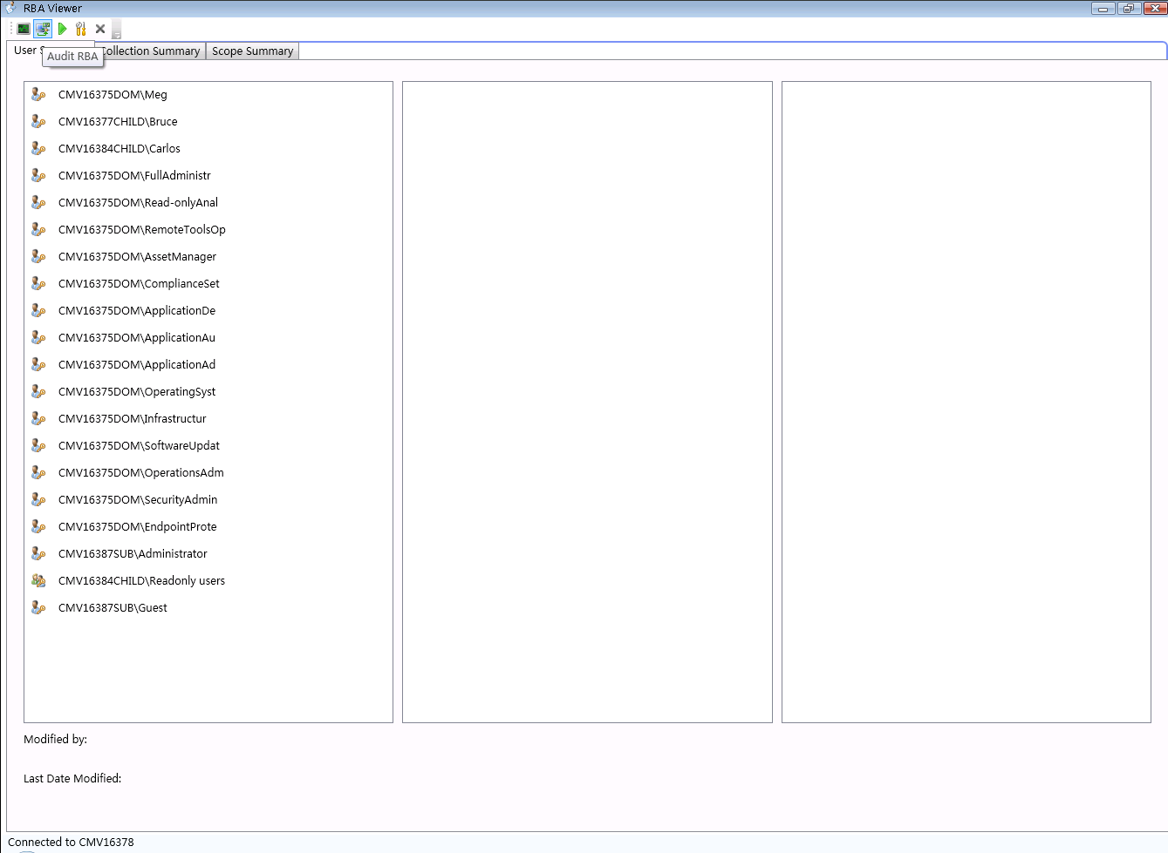

**Audit RBA configuration for a specific user**

Select the Run As button in toolbar tray. You can input the specific user name to check the permissions for that user account. You will see the security roles assigned to the user or the security group the user belongs to.

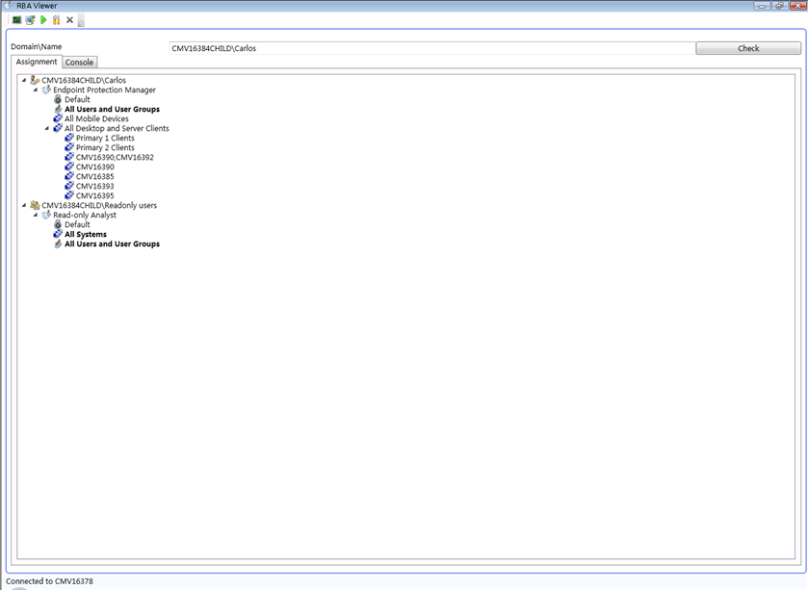

The object this user can see and the action this user can launch will be displayed. 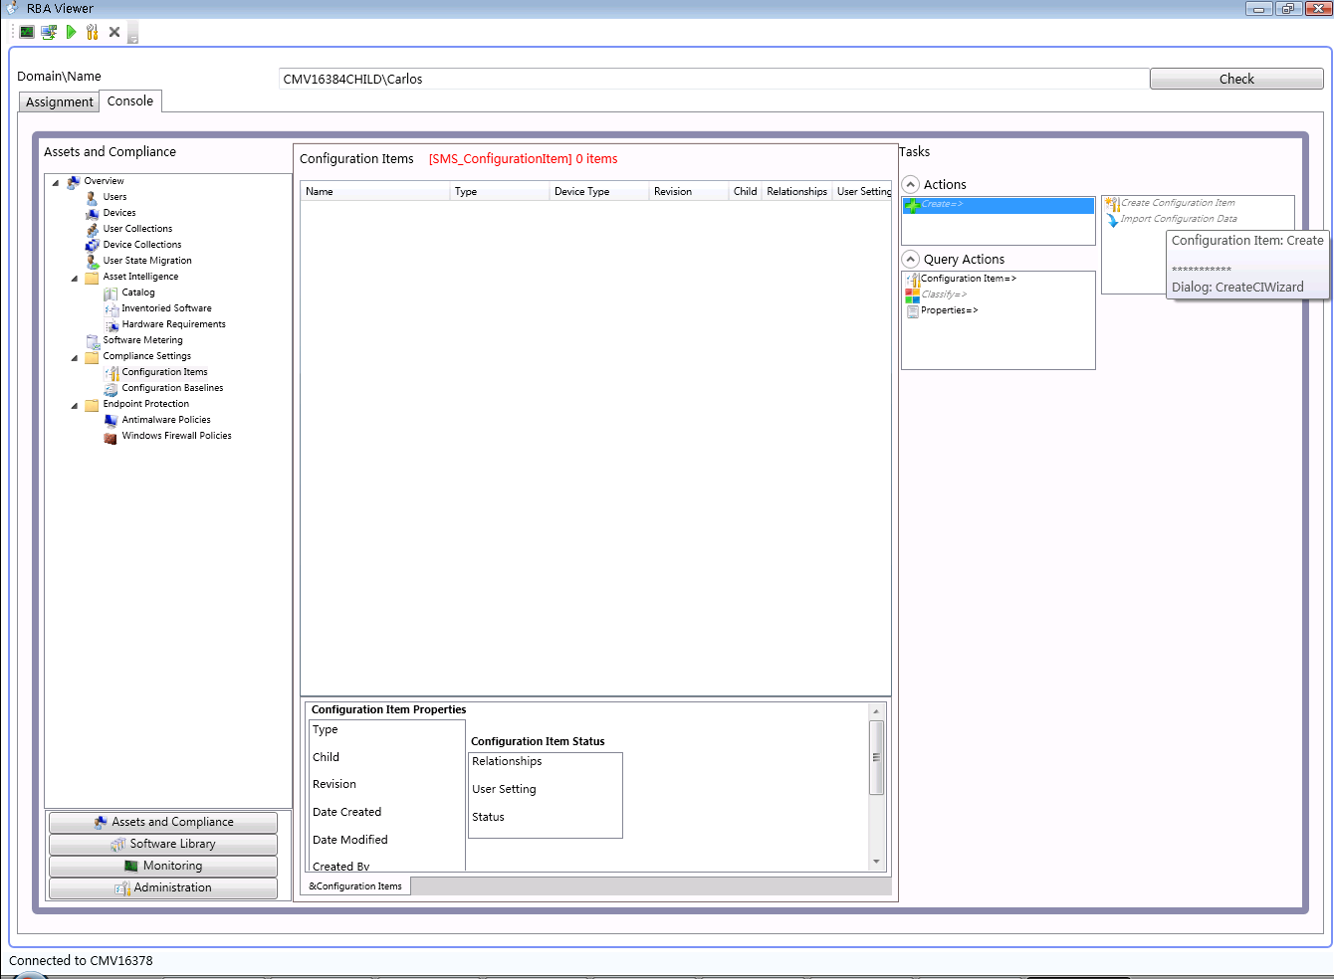

**View relationship between report folders and security objects.**

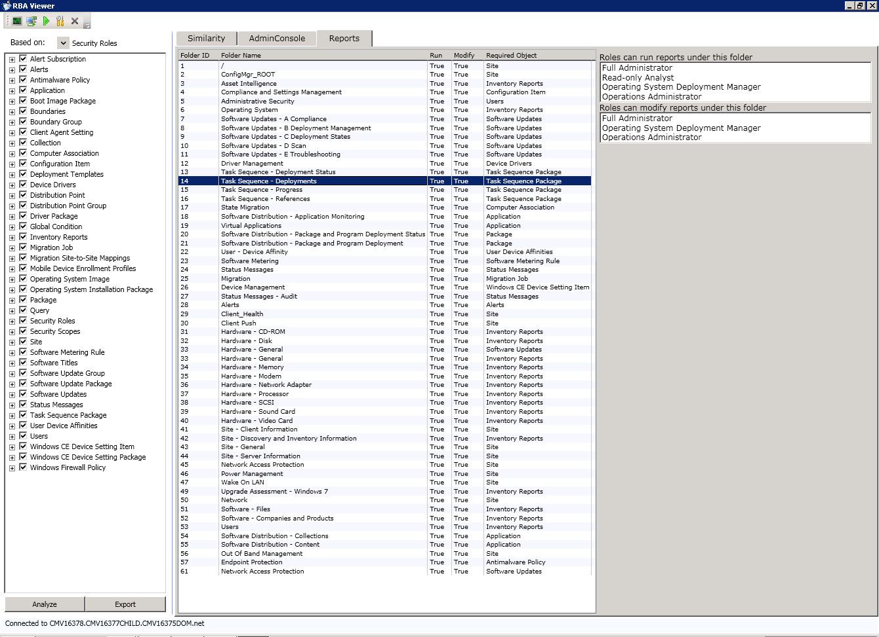

## Run Metering Summarization (runmetersumm.exe)

The RunMeterSumm tool is used to trigger Metering Summarization immediately on Primary Sites, by default it’s running as scheduled in Site Maintenance tasks, which start after 12:00AM every day. These tasks summarize the data in table MeterData, and write the summary result into the tables FileUsageSummary and MonthlyUsageSummary, so the user can see the summarized result in metering reports. The administrator who can connect to the primary site database can use this tool to run summarization.

This program will run the File Usage Summary and Monthly Usage Summary Software Metering data summarization tasks. It will summarize all existing meter data without the usual 12 hour waiting period. It must be run on the Local SQL server computer for the SMS site. The exit code will be set to 0 if summarization was successful and 1 if there was an error.

**Usage**

**Command Line:**

runmetersumm [sms database name] <delay in hours for summarization <default=0>>

**Options:**

<delay in hours for summarization <default=0>> - runmetersumm will just summarize the software metering usage generated before the delay.

**Example:**

runmetersumm [sms database name] <12> will summarize the software metering usage generated 12 hours ago.

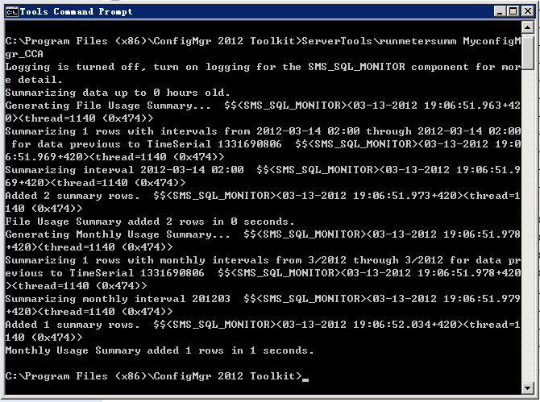A successful execution should looks like:

## Content Ownership Manager Tool

The Content Ownership Manager tool changes ownership of orphaned packages in System Center Configuration Manager 2012 SP1. Orphaned packages are packages without an owner site server. Packages that are created at a site can become orphaned by removing the site server while they are still owned by this site server.

The Content Ownership Manager tool runs on any site server computer in the Configuration Manager hierarchy. The tool must be run while logged in as an Administrative User that has sufficient package permissions in Configuration Manager.

Content Ownership Manager Tool features:

1. Display all orphaned packages
2. Display all packages, even if they are not orphaned
3. View the status of the connection to a site
4. Filter packages by name, site code or package type
5. Sort by any displayed column
6. Change assignment of one or more packages with a single action.
7. View progress of the ownership transfer activity.

**Usage**

Launch the Content Ownership Manager tool by using the shortcut created during installation, or by running the “ContentOwnershipTool.exe” from the toolkit installation path. Local administrator permissions on the computer are not required to run the tool.

There are no command line parameters that can be specified.

A view of the Content Ownership Manager tool.

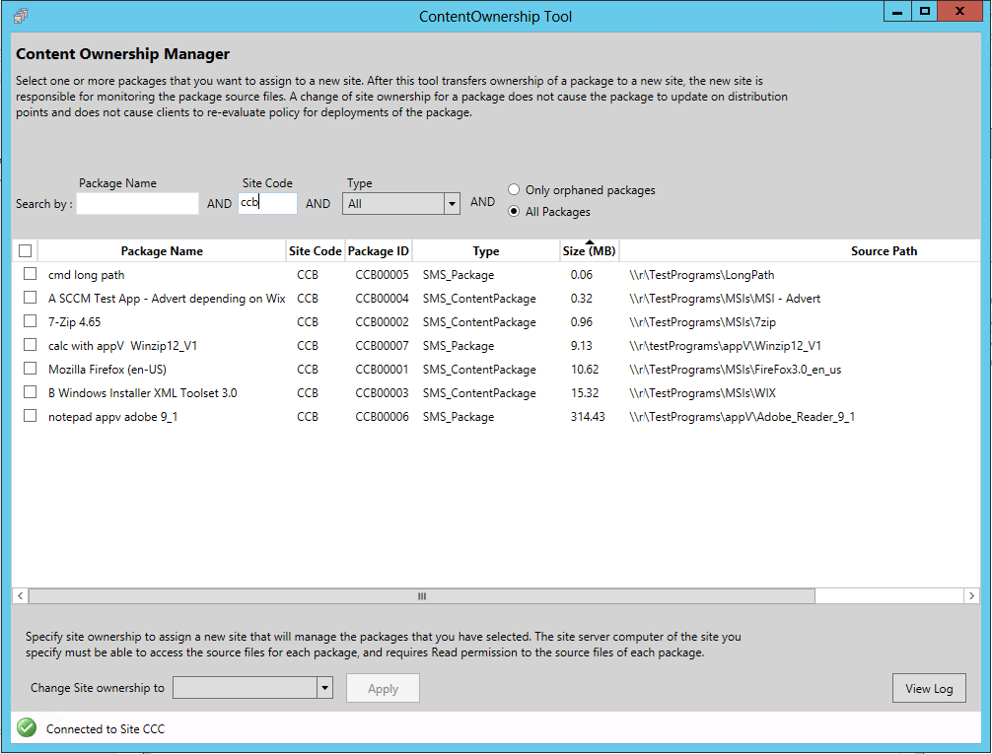

**Important**

This tool changes the ownership of an orphaned package, but the package itself does not move from the distribution point that it is stored on. Therefore, this ownership change does not cause the package to update on distribution points and does not cause clients to re-evaluate policy for deployment of the package. After this ownership changes, ensure that the new site owner computer can access the source files and has at least “Read” permissions to the source files of each package.

## Content Library Transfer Tool

The Content Library Transfer tool transfers content from one disk drive to another. It is designed to run on distribution point site systems. The tool supports distribution points co-located with a site or they can be remote.

The tool is useful for the scenario when the disk drive hosting the content library becomes full. After a hard disk is installed (or identified) with sufficient space to host the content library, ContentLibraryTransfer.exe is used transfer content from the old filled hard disk to the new (empty) drive.

Once the transfer is complete, content is now accessible to client computers from the new location without admin intervention.

**Usage**

**ContentLibraryTransfer.exe** must be run as using an account that has administrative permissions on the distribution point site system.

**Syntax**:

ContentLibraryTransfer.exe –SourceDrive <drive letter of source drive> –TargetDrive <drive letter of destination drive>

**Example:**

ContentLibraryTransfer –SourceDrive E –TargetDrive G

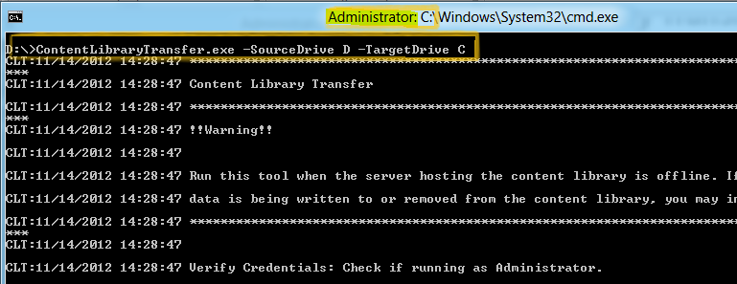

**Limitations**

1. The tool must run locally on the distribution point; it cannot be run from a remote machine.
2. The tool must run only when the distribution point is not actively being accessed by client computers. If the tool is run while client computers are accessing the content, the content library on the destination drive may have incomplete data or the data transfer might fail altogether leading to an unusable content library.
3. The tool must only run when no content is being distributed to the distribution point. If the tool is run while content is being written to the distribution point, the content library on the destination drive may have incomplete data or the data transfer might fail altogether leading to an unusable content library.

## Content Library Explorer Tool

The Content Library Explorer allows for exploration of the content library on a specific distribution point. This tool can be used to troubleshoot issues with the content library, as well as explore its contents. Using the tool, packages, contents, folders, and files can all be copied out of the content library. Packages can be redistributed to the distribution point, and on remote distribution points, packages can be validated.

**Usage**

**ContentLibraryExplorer.exe** must be run using an account that has administrative access to the target distribution point, as well as access to the WMI provider on the site server and the Configuration Manager provider. In particular, only the RBAC roles Full Administrator and Read-Only Analyst have sufficient rights to view all information from this tool. Other roles, such as Application Administrator, can view partial information (see note below on disabled packages). The Read-Only Analyst cannot redistribute packages from this tool.

The toolcan be run from any machine, as long as it can connect to the distribution point, the primary site server, and the Configuration Manager provider. If the distribution point is co-located with the site server, it is still necessary to have administrative access to the site server.

When the application is started, you must enter in the FQDN (Fully Qualified Domain Name) of the target distribution point. The application then connects to the distribution point. If the distribution point is part of a secondary site, you will also be prompted for the FQDN of the primary site server, and the primary site code.

In the left pane, the packages distributed to this distribution point are visible. They can be expanded, and their folder structure explored. This will match the folder structure from which the package was created. When a folder is selected, if it contains any files, these will be listed in the right pane. Information is provided about file name, file size, which drive it is present on, other packages that use the same file on the drive, and when the file was last changed on the distribution point.

The application also connects to the Configuration Manager provider machine, in order to determine which packages are distributed to the distribution point, whether or not they are actually in the distribution point’s content library. For instance, a package that is pending distribution may not yet exist in the content library. Such a package would appear as “PENDING” in the tool, and no actions will be enabled for this package.

Disabled packages: Some packages are present on the distribution point but not visible in the Configuration Manager console. These packages are marked with an asterisk (*). No actions may be performed on these packages. Other packages may also be marked with an asterisk and have actions disabled. There are three primary reasons for which this might occur:

1. The package is the Configuration Manager client upgrade package. This would contain “ccmsetup.exe”.
2. The package is not accessible by the running user’s RBAC rights. For instance, the Application Author role cannot see driver packages in the console, so any driver packages on the distribution point will marked.
3. The package is orphaned on the distribution point.

Packages can be validated by using Package > Validate on the tool strip. A package node must be selected in the left pane, not a content or folder. The tool connects to the WMI provider on the distribution point to do this. When the tool starts, packages that are missing one or more contents will be marked invalid. Validating the package will reveal which contents are missing. If all contents are present but the data is corrupted, validation will detect the corruption.

Additionally, packages can be redistributed using Package > Redistribute on the tool strip. Again, a package node must be selected in the left pane. This requires permission to redistribute packages.

Using Edit > Copy, packages, contents, folders, and files can be copied out of the content library to a specified folder. The content library itself cannot be copied. Multiple files can be selected (using Ctrl + click or Shift + click), but multiple folders cannot.

Packages can be searched using Edit > Find Package. This will search for your query in the package name and package ID.

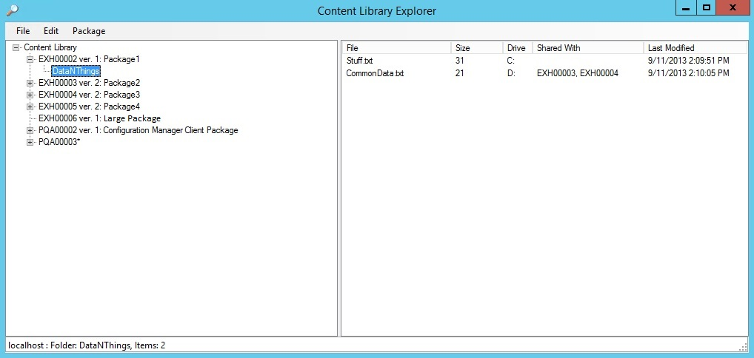

**Limitations**

1. The tool cannot manipulate the content library directly in any way. Changes to the content library may result in malfunctions.
2. The tool can redistribute packages, but only to the target distribution point.
3. When the distribution point is co-located with the site server, package data cannot be validated. Please use the Configuration Manager console. (It will still inspect to make sure that all the package contents are present, though not necessarily intact).
4. Content cannot be deleted using this tool.

## 2.7 Collection Evaluation Viewer (CEViewer.exe)

The Collection Evaluation Viewer (CEViever.exe) is a tool for viewing the collection evaluation processes. It is intended to assist in troubleshooting collection evaluation related issues via computers running System Center Configuration Manager on the primary site server.

The tool displays both historic and live information for full and incremental collection evaluations and the evaluation queue status. It will provide information on the time for collection evaluations to complete, which collections are currently being evaluated, and the estimated time that a collection evaluation will start and complete.

**About collection evaluation**

The collection evaluation process runs by evaluating the membership rules of a collection to update its members. A collection that is being evaluated will be placed in one of four different queues:

Manual Queue For collections that have been manually selected for evaluation from the Administrator console UI

New Queue For newly created collections

Full Queue For collections due for full evaluation

Incremental Queue For collections with incremental evaluation

There are four threads that run to evaluate the collections in the above queues. Each queue includes a series of arrays, and each array includes the collections to be evaluated. The thread that is running for the queue selects a collection from the array and runs the evaluation. The queue length indicates the number of arrays in the queue.

For more information on collection evaluation please see product documentation.

**Requirements**

This tool should be run on the site server machine.

This tool should be run by a user with the Read Only Analyst role.

Read permission to the site database in SQL is required for this tool to run.

**Usage**

The main menu of the tool contains nine tabs:

|  |  |
| --- | --- |
| Tab | Summary |
| Connect | Allows user to establish the initial connection to the primary site server and SQL Server |
| Full Evaluation | Lists the detailed information about all full evaluations that happened in the past |
| Incremental evaluation | Lists the detailed information about all incremental evaluations that happened in the past |
| All Queues | Summarizes the current collection evaluations for all four queues |
| Manual Queue | Lists the detailed information about the current collection evaluation in the manual queue |
| New Queue | Lists the detailed information about the current collection evaluation in the new queue |
| Full Queue | Lists the detailed information about the current collection evaluation in the full queue |
| Incremental Queue | Lists the detailed information about the current collection evaluation in the incremental queue |
| Help | Shows the copyright information and a basic overview of the Collection Evaluation Viewer |

**Connect Tab**

This tab allows users to establish the initial connection to the primary site server. The tool establishes a connection to the SQL server that hosts the site database.

The connections to both primary site server and SQL servers use the current logged on user credential. Connections to the CAS or secondary site is not supported since there is no collection evaluation process that runs on them.

Once the connection is successfully established, users can see a notification at the bottom of the Collection Evaluation Viewer that confirms the tool is connected to the SQL server.

**Full Evaluation Tab**

Shows detailed information about full collection evaluations that happened in the past.

There are eight columns:

1. **Collection Name**: Name of the collection
2. **Site ID:** Site ID of the collection
3. **Run Time:** The time that the last collection evaluation took, in seconds.
4. **Last Evaluation Completion Time**: The time that the last collection evaluation completed.
5. **Next Evaluation Time**: The time that the next full evaluation will start.
6. **Member Changes**: The member changes in the last collection evaluation, either plus (members added) or minus (members removed).
7. **Last Member Change Time**: The most recent time that there was a membership change in the collection evaluation
8. **Percent**: The percentage of evaluation time for this collection over the total (all collections) evaluation time

**Incremental Evaluation Tab**

Shows detailed information about incremental collection evaluations that happened in the past.

There are seven columns:

1. **Collection Name**: Name of the collection
2. **Site ID:** Site ID of the collection
3. **Run Time:** The time that the last collection evaluation took, in seconds.
4. **Last Evaluation Completion Time**: The time that the last collection evaluation completed.
5. **Member Changes**: The member changes in the last collection evaluation, either plus (members added) or minus (members removed).
6. **Last Member Change Time**: The most recent time that there was a member change in the collection evaluation
7. **Percent**: The percentage of evaluation time for this collection over the total (all collections) evaluation time

**All Queues Tab**

Summarizes the live collection evaluations for all four queues

There are six sections:

1. **Summary**: Lists the total collection number and the queue length for all collections in all four queues
2. **Running Evaluation**: Lists which collection is currently being evaluated in each queue and how long it has been running.
3. **Manual Update**: Shows a brief summary of the collections being evaluated, the estimated completion time and the order of the evaluation in the manual queue.
4. **New Collection**: Shows a brief summary of the collections being evaluated, the estimated completion time and the order of the evaluation in the new collection queue.
5. **Full Evaluation**: Shows a brief summary of the collections being evaluated, the estimated completion time and the order of the evaluation in the full evaluation queue.
6. **Incremental Evaluation**: Shows a brief summary of the collections being evaluated, the estimated completion time, and the order of the evaluation in the incremental evaluation queue.

**Manual Queue Tab**

Shows information about the manual collection evaluation currently being evaluated. The order in the list is the order in which the collection will be evaluated.

There are four columns:

1. **Collection Name**: Name of the collection.
2. **Site ID:** Site ID of the collection.
3. **Estimated Completion Time**: The estimated time that the evaluation will complete.
4. **Estimated Run Time**: The estimated time that the evaluation will complete, in day:hour:minute:second format.

**New Queue Tab**

Shows the live information about the new collection evaluation being evaluated, the order in the list is the order in which the collection will be evaluated.

There are four columns:

1. **Collection Name**: Name of the collection.
2. **Site ID:** Site ID of the collection.
3. **Estimated Completion Time**: The estimated time that the evaluation will complete.
4. **Estimated Run Time**: The estimated time that the evaluation will complete, in day:hour:minute:second format.

**Full Queue Tab**

Shows information about the full collection evaluation currently being evaluated, the order in the list is the order in which the collection will be evaluated.

There are four columns:

1. **Collection Name**: Name of the collection.
2. **Site ID:** Site ID of the collection.
3. **Estimated Completion Time**: The estimated time that the evaluation will complete.
4. **Estimated Run Time**: The estimated time that the evaluation will complete, in day:hour:minute:second format.

**Incremental Queue Tab**

Shows information about the incremental collection evaluation currently being evaluated, the order in the list is the order in which the collection will be evaluated.

There are four columns:

1. **Collection Name**: Name of the collection.
2. **Site ID:** Site ID of the collection.
3. **Estimated Completion Time**: The estimated time that the evaluation will complete.
4. **Estimated Run Time**: The estimated time that the evaluation will complete, in day:hour:minute:second format.

**Help Tab**

Contains the copyright information and a basic overview of the Collection Evaluation Viewer.

## 2.8 Distribution Point Job Queue Manager (DPJobMgr.exe)

Distribution Point Job Queue Manager (DPJobMgr.exe) is a tool for troubleshooting and managing ongoing content distribution jobs to System Center Distribution Points..

The tool displays the list of jobs that the package transfer manager component has in its queue as well as the status of the jobs (ready to be executed, running or retrying). The tool also allows manipulation of the jobs in the queue, moving jobs higher on the list, cancelling or even kick start running a job manually.

The information on which distribution point the job is running on can also be obtained, but the important thing is to remember that this list is what site server knows, the tool connects through the provider to the site server, and doesn’t connect to each remote distribution point and gather this information. Because actions such as cancelling a running job or getting exact progress of the job on remote distribution points are invoked by using the provider, there is a delay before the tool can reflect the changes from the remote distribution points.

For more information on distribution point and package priority, concurrent software distribution settings and what this list means for regular distribution points vs. Pull-distribution points please see product documentation [here](http://technet.microsoft.com/en-us/library/gg712321.aspx).

**Usage**

The main menu of the tool contains five tabs:

|  |  |
| --- | --- |
| Tab | Summary |
| Connect | Allows you to establish the initial connection to the primary site server. |
| Overview | Summarizes all the jobs that are running on all distribution points in a single view. |
| Distribution Point Info | Allows users to track certain distribution points by allowing them to multi select distribution points. Users can right click and manage a single job that they are interested |
| Manage Jobs | Shows list of all the jobs and their statuses in one flat view. Users can manipulate jobs, move them up, cancel or manually kick start. Drag and drop are supported in this page. |
| Help | Show the copyright information and quick information on what the icons that are used in the tool represent. |

**Connect Tab**

This tab allows users to establish the initial connection to the primary site server. The connection to the primary site server uses the logged on user credential. Connect to CAS and secondary site is not supported. The full SCCM administrator is required for the connection.

Once the connection is successfully established users can see a notification at the bottom of the tool that confirms that the tool is connected to the site server.

**Overview Tab**

Shows the summary of all the jobs on all distribution points.

There are five columns:

1. **Distribution Point**: Lists the names of the distribution points
2. **Running Jobs:** Shows the number of concurrent jobs that are running on a particular distribution point.

**Note:** Number of concurrent software distributions is a setting that can be modified in **Software Distribution Component Properties**.

1. **Total Jobs:** Shows the number of all the jobs that are targeted to a particular distribution point. This number includes the jobs that are running, retrying, or waiting to be executed.
2. **Total Retries:** Shows the number of times jobs have been retrying in a particular distribution point. Higher number may represent a general problem in that particular distribution point.

**Note**

* Each column in this tab can be sorted A->Z or Z->A by clicking on the column name.
* List in this tab can be refreshed manually by clicking on the “Refresh” button
* List in this tab can also be refreshed automatically by clicking on the “Start Auto Refresh” button and setting the default auto refresh interval (default is 2 minutes)

**Distribution Point Info Tab**

Shows the list of all the distribution points under the particular site that the tool is connected to.

List of all the distribution points can be seen on the left hand side pane, users can “Select All” or “Unselect All” distribution points in this list by using the corresponding buttons. There is also an option to multi select distribution points by selecting them on the list.

The right hand pane will show the jobs only for the selected distribution points.

There are eight columns:

1. **Status Icon:** There are three possible status icons
   1. **Ready (****)**: Indicates that a particular job has finished all the verification steps and ready to be added to the running concurrent jobs. Jobs in this status are usually in a waiting stage, they wait for the current running processes to finish to open up a space for them.
   2. **Running (****)**: Indicates that a particular job is currently running on a distribution point. For long running jobs (big packages) usually there is time to get the progress (%) of the completion and shown under “Progress” column in this view. For small packages “Progress” column may stay empty since the job may already be completed by the time the status from the remote distribution point.
   3. **Retry (****)**: Indicates that a particular job has failed and now in retry state. This job will be retried after default retry interval (configurable by default 30 min)
2. **Software**: Name of the package that is targeted to a particular distribution point.
3. **Package ID**: Package ID of the package that is targeted to a particular distribution point
4. **Size**: Size of the package in KB
5. **Progress**: Job completion percentage
6. **Start/Restart Time**: For a running job, this is the start time (green color); For a retry job, this is the time that the job will be retried.
7. **Retries**: Number of times this package has been retried.
8. **Distribution Point Name**: Name of the distribution point (FQDN)

**Note**

* Each column in this tab can be sorted A->Z or Z->A by clicking on the column name.
* List in this tab can be refreshed manually by clicking on the “Refresh” button
* List in this tab can also be refreshed automatically by clicking on the “Start Auto Refresh” button and setting the default auto refresh interval (default is 2 minutes)
* If a particular job is required to be modified, users can right click a particular job in this view and by selecting “Manage Job”, they can be taken to the “Manage Jobs” tab

**Manage Jobs Tab**

Shows list of all the jobs and their statuses in one flat view.

Contains the same eight columns as the “Distribution Point Info” tab, but now all the jobs can be right clicked for certain actions:

1. **Run**: Kick starts a job that is in any state other than running
2. **Move To Top:** Moves one or multiple jobs to the top of the queue, this may result in this jobs to start running immediately. A lower priority job can pause running as a consequence of this action.
3. **Move Up**: Moves a particular job one row above, a lower priority job can pause running as a consequence of this action.
4. **Move Down**: Moves a particular job one row below.
5. **Move To Bottom**: Moves one or multiple jobs to the bottom of the queue.
6. **Cancel**: Tries to cancel one or multiple jobs. Note that jobs that are near their final completion time or jobs that are on site server (if the site server is also a distribution point) cannot be cancelled.

Drag and drop are supported move the move actions.

**Help Tab**

Contains the copyright information and the simple information about the status icons that are explained in the “Distribution Point Info” section of this guide.